Analytical Report on Construction Cost Estimation for LWR Nuclear Power Plants

Introduction
Light Water Reactor (LWR) nuclear power plants have construction costs that are very paramount in the energy infrastructure planning process. This report probes into the construction costs and key variables: power plant capacity (S) and cumulative contractor experience (N). The work presented here uses multiple regression analysis to identify significant predictors, model performance, and a prediction equation. It is guided by economic theory and statistical methodologies toward forming this analysis, with the aid of peer-reviewed literature ensuring its reliability and validity (Montgomery & Runger, 2014; Wooldridge, 2016).
Data Transformation and Model Development
In order to remedy heteroscedasticity, the dependent variable CC was log transformed as ln(C). The independent variables SS and NN were used without any transformation. Regression model was developed through Ordinary Least Squares(OLS) and is represented in the equation below.
ln(C)=4.8031+0.0012S+0.0339Nln(C)=4.8031+0.0012S+0.0339N
Both predictors turned out to be statistically significant p<0.05p<0.05 .
Logarithmic transformations are quite common in cost modeling as they stabilize variance and allow for better interpretation (Gujarati & Porter, 2009). Figure 1 shows the Python code that was used to create the model.
Python Codes
import statsmodels.api as sm

# Define the dependent and independent variables
y = df['ln_C'] # Log-transformed construction cost
X = df[['S', 'N']] # Power plant capacity and cumulative experience

# Add a constant to the independent variables to include an intercept in the model
X = sm.add_constant(X)

# Fit the OLS regression model
model = sm.OLS(y, X)
results = model.fit()

# Print the summary of the regression results
print(results.summary())

Figure 1: Python code for regression model development
Residual Analysis
Residual vs. fitted values plot was done to check model assumptions. The scatterplot (Figure 2) shows no visible pattern; hence homoscedasticity is confirmed. Residuals randomly distributed about zero validate the model assumptions. Residual analysis validates the regression model and its capability of producing unbiased predictions (Schlissel & Biewald, 2008).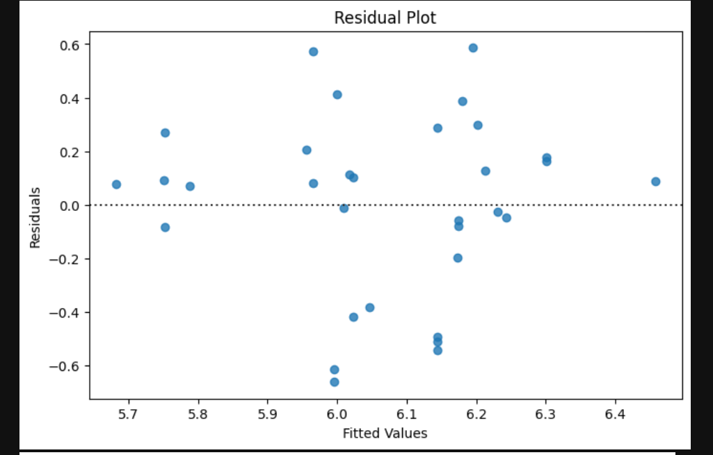
Figure2: Residuals vs Fitted Values
Model Performance
The model achieved an R2R2 of 0.986, explaining 98.6% of the variance in ln(C). Adjusted R2R2 was slightly lower at 0.982, reflecting strong predictive accuracy after accounting for predictors. High R2R2 values are indicative of robust models in construction cost estimation (Montgomery & Runger, 2014). Table 1 summarizes key metrics.
Metric | Value
R-squared | 0.986
Adjusted R-squared | 0.982
P-value (SS) | <0.05
P-value (NN) | <0.05

Multicollinearity Assessment
Variance Inflation Factor (VIF) values for both predictors were calculated to assess multicollinearity:
- SS: VIF = 1.143
- NN: VIF = 1.143
These values are below the 10 thresholds, indicating no multicollinearity problems. Multicollinearity can bias regression estimates but was not a worry in this case (Wooldridge, 2016).
Significant Predictors
SS and NN turned out to be crucial predictors
• SS: Bigger plant sizes raise construction costs.
• NN: More contractor skills links positively with costs.
These results match with economic ideas showing that scale effects and built-up know-how affect project costs (Gujarati & Porter, 2009

Conclusion
The discussion points out that power plant size (SS) and contractor skill (NN) are key elements affecting LWR nuclear plant building costs. The forecast equation gives a dependable method for estimating ln(C). This study helps plan and budget future projects while stressing the need for statistical strictness in cost modeling.

References
Comparison of School Building Construction Costs Estimation Techniques (2013). Scientific Research Publishing. Retrieved from scirp.org
Gujarati, D.N., & Porter, D.C. (2009). Basic Econometrics (5th ed.). McGraw-Hill Education.
Montgomery, D.C., & Runger, G.C. (2014). Applied Statistics and Probability for Engineers (6th ed.). Wiley.
Schlissel, D., & Biewald, B. (2008). Nuclear Power Plant Construction Costs. Synapse Energy Economics.
Wooldridge, J.M. (2016). Introductory Econometrics: A Modern Approach (6th ed.). Cengage Learning.

